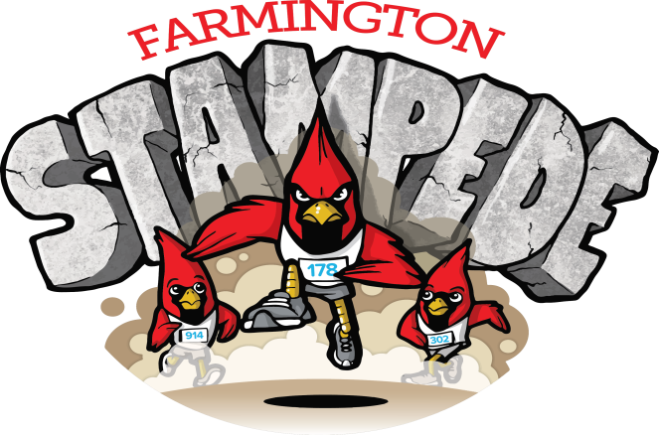

ANNUAL FARMINGTON STAMPEDE
August 26, 2017
DONATION LEVELS AND BENEFITS
We would like to invite you to participate in our fundraising event for “Back to School Bonanza” in Farmington. We expect this Farmington Stampede to not only be a great fundraiser for Back to School Bonanza, but will promote healthy families and children.

Back to School Bonanza is possible through donations and provides tennis shoes, socks, underwear, soap, shampoo, deodorant, haircuts, backpacks, dental and vision screenings, Kindergarten health physicals, and Bibles to kids in grades K-12 from any school district that wants to come, without any income requirements or registration. Organizers raise approximately $10,000 every year for this event.

We started Farmington Stampede to be a fun community event to benefit the needs of children and introduce them to running as a sport. Back to School Bonanza has been an important part of the Farmington Community for 11 years and is hosted by the United Methodist Church in Farmington. The Farmington Stampede will help provide funds to be used for kids in our region by supporting Back to School Bonanza. A portion of this year’s proceeds will also benefit Farmington’s Cross Country program. This event is organized by the non profit, Fitness for Fun, Inc. Please make checks payable to Fitness for Fun, Inc.

Here are some things you can do to help make Farmington Stampede a great success!
1. You can register & participate in the Farmington Stampede.
2. You can make a tax deductible donation to Fitness for Fun, Inc. or you can be a sponsor for the event.
3. We will also need many items donated for this event. If you would be interested in this option, please contact me for a complete list of needed items.

It’s not just a fun community event that’s healthy for the whole family, but you will be supporting an event that helps the children in our region.

If you should have any questions please contact me at (479)267-2664 or email Sheryl Cash at farmingtonstampede@gmail.com. Mailing address is:
13702 Goose Creek Rd. Fayetteville, AR 72704

Thank you in advance for your support of the Farmington Stampede!

DONATION LEVELS AND BENEFITS  PLATINUM  $1000 + | Platinum sponsors receive:  Large logo printed on race entry t-shirt and website, recognition on our facebook page as a sponsor. A sponsor provided banner at race venue.
GOLD  $750 + | Gold sponsors receive:  Large Logo printed on the race entry t-shirt and website, recognition on our facebook page as a sponsor.
SILVER  $500 + | Silver sponsors receive:  Small Logo placed on Race website & small logo on race entry t-shirt.
BRONZE  $250 + | Bronze sponsors receive:  Small logo placed on the race entry t-shirt & name printed on the race website
ALUMINUM  $125 + | Aluminum sponsors receive:  Name printed on the race entry t-shirt & race website
Cardinal  $50 | Cardinal Sponsor receives:  Name listed on the website as a sponsor.

ALL SPONSORS & PARTICIPANTS MUST HAVE A COMPLETE FORM
Contact Name____________________________________ Phone___________________________
Address_________________________________________ Email____________________________
Sponsorship or donation amount $_________ is attached
I would like my name(s) to appear on the Farmington Stampede materials as follows:
________________________________________________________________________
All payments must be received prior to logos or names being submitted and all sponsor logos must be HI-Res .jpg format & emailed to farmingtonstampede@gmail.com (Checks payable to Fitness for Fun, Inc.)

THANK YOU FOR SUPPORTING THE FARMINGTON STAMPEDE
You can also register at racewizard.com

ANNUAL FARMINGTON STAMPEDE
Aug. 26, 2017
RACE REGISTRATION
Name of Runner: __________________________________________________________________
Runner's Date of Birth: _______________________ Runner’s Gender: M F
Circle One: 5K run/walk or 1mile fun run/race
Terms: In consideration of acceptance of this entry, I waive, release, and forever discharge any and all claims, rights, and causes of action against sponsors, organizers, and representatives of the Farmington Stampede 5K, and 1 mile fun run for injury or illness that may result from participation in the race or surrounding events. I am in proper physical condition to participate in this event. I understand that no one has undertaken to provide me with any medical care, treatment, or advice concerning my participation in this event. Additionally, I agree that photos may be taken of me during the event and I authorize these photos to be used in promoting the Farmington Stampede, in print and on the internet. I release the sponsors, organizers, and representatives of any liability associated with those photos.
Signature of Runner: _____________________________
Date: ___________________________
Signature of Parent/Guardian:______________________ Date:___________________________
(if runner is under 18)

